**Map Projections and Coordinate Systems**

**Outline**

1.      Map Projections

o        Basic Principles

▪         Earth’s Shape and Vertical Datum

▪         Geographic Coordinate System (latitude and longitude)

▪         Map Projections Defined

o        Types of Projections.

▪         Azimuthal

▪         Cylindrical

▪         Conic

▪         Mathematical

o        Projection distance, area and shape

▪         Equal Area

▪         Conformal

▪         Distance

▪         Compromise

o        Common GIS Projections

▪         Mercator

▪         Lambert Conformal Conic

▪         State Plane

▪         Lambert Equal Area

2.      Coordinate Systems

o        General

o        State Plane Coordinates

▪         Every State has at least one

▪         Based on origins identified by each state

▪         Identified on US Quadrangle maps

o        Universal Transverse Mercator

▪         Transverse (uses longitude as standard line) cylindrical projection

▪         60 Zones

o        United States Public Land Survey System

3.      GIS Capabilities

o        Basic Concepts

o        Selecting the proper projection

4.      Questions

**1. Map Projections**

**Basic Principles**

* Although for many mapping applications the earth can be assumed to be a perfect sphere, there is a difference between the distances around the earth between the poles versus the equator.  The circumference of the earth is about 1/300th smaller around the poles. This type of figure is termed an oblate ellipsoid or spheroid, and is the three-dimensional shape obtained by rotating an ellipse about its shorter axis. An estimate of the earth’s surface based on an ellipsoid provides a determination of the elevation of every point on the earth’s surface, including sea level, and is often called a datum. Over time, and in different countries, many datums have been developed and used. With more accurate means of measurement today (i.e. satellite and GPS), recent datums are referenced from the center of the earth rather than a theoretical surface.  The resulting North American Datum of 1983 (NAD83)and the slightly refined World Geodetic System (WGS84), from the U.S. Military in 1984, are internationally accepted as the geodetic reference system (GRS 80).
* Geographic Coordinates simply refers to the system of latitude and longitude. This coordinate system is formed by creating a grid using the equator as 0 degrees and forming parallels of latitude to the north and south (90 degrees N is the North Pole, 90 degrees S is the South Pole), and meridians of longitude east and west (which meet at 180 degrees, commonly called the International Date Line) of the "Prime Meridian" which passes through Greenwich, England.
* Map projections are used to transfer or “project” geographical coordinates onto a flat surface.

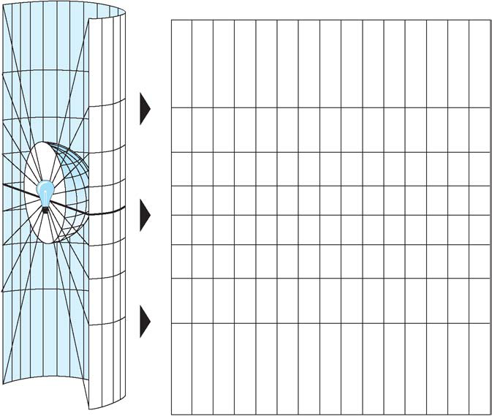

The easiest way to try to transfer the information onto a flat surface is to convert the geographic coordinates into an X and Y coordinate system, where x is longitude and y is latitude. This is an example of “projecting” onto a plane.  Coordinates can also be "projected" onto two other flat surfaces, a cylinder or cone, and then unfolded into a map. The grid formed by the latitude and longitude on a map is called the graticule.  There are thousands of different map projections all depending on how they intersect earth’s surface and how they are oriented.  For example, the line of latitude or longitude where a projection intersects or “cuts” the earth’s surface is called the point of contact, or standard line, where distortion is minimized.  Orientations of the three shapes can also vary between equatorial (standard lines of latitude), transverse (standard lines of longitude), and oblique (standard line other than latitude or longitude).  In addition, each projection effects the distance, area, and angle relationships of the earth surface as portrayed on the map. Ideally, these factors would be consistent to the relationships on the real earth. Unfortunately, some relationships are always distorted.

**Types of Projections**

* An azimuthal or planar projection is usually tangent to a specific point on earth’s surface, but may also be secant. This point, or focus, may be a pole, the equator, or other oblique point.  Normally though, the azimuthal projection is used for polar charts due to distortion at other latitudes.
* A cylindrical projection usually places the earth inside a cylinder with the equator tangent or secant to the inside of the cylinder.  If the cylinder is placed perpendicular to the axis of the earth, the resulting projection is called a transverse projection.

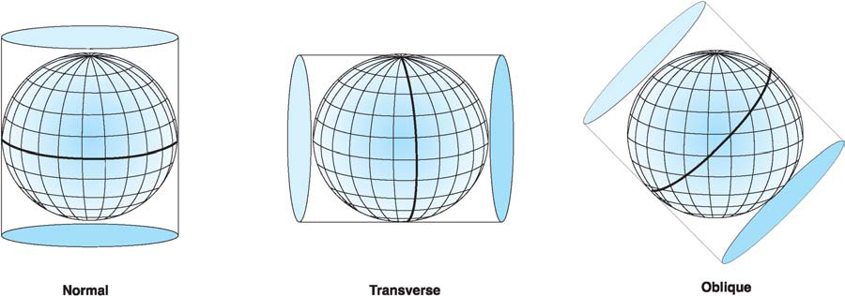

* In a conic projection, a cone is placed over the earth, normally tangent to one or more lines of latitude. This tangent line is called a standard parallel and, in general, distortion increases the further away you get from this line.  A conic projection works best over mid latitudes for this reason.
* Mathematical map projections are not based on developable surface, but often specify a direct mathematical projection from a spheroid onto a flat surface.  These types of map projections can change for different parts or regions of the world in order to reduce certain distortions.  They can also be formed by merging other projections in order to get the “best” of each.

**Projection Distance, Area, and Shape**

* Equal area projections preserve the property of area. On an equivalent projection all parts of the earth's surface are shown with the correct area. However, latitudinal distances are never accurate.
* Conformal projections preserve right angles between lines of latitude and longitude and are primarily used because they preserve direction. Area is always distorted on conformal maps. Because of GIS’s emphasis on cartographic shapes, GIS systems often use conformal projections.
* Some projections only preserve correct distance relationships along a few lines on the map. For example, an Equidistant azimuthal projection has the distance to the outside of the map portrayed correctly. These are seldom used in GIS.
* A final category is compromise maps. They may be the average of two or more projections or interrupted or broken in order to minimize certain distortions.

**Common GIS Projections**

* Mercator- A conformal, cylindrical projection tangent to the equator.  Originally created to display accurate compass bearings for sea travel. An additional feature of this projection is that all local shapes are accurate and clearly defined.
* Transverse Mercator - Similar to the Mercator except that the cylinder is tangent along a meridian instead of the equator. The result is a conformal projection that minimizes distortion along a north-south line, but does not maintain true directions.
* Universal Transverse Mercator (UTM) – Based on a Transverse Mercator projection centered in the middle of zones that are 6 degrees in longitude wide.  These zones have been created throughout the world.
* Lambert Conformal Conic – A conic, confromal projection typically intersecting parallels of latitude, standard parallels, in the northern hemisphere.  This projection is one of the best for middle latitudes because distortion is lowest in the band between the standard parallels. It is similar to the Albers Conic Equal Area projection except that the Lambert Conformal Conic projection portrays shape more accurately than area.
* State Plane – A standard set of projections for the United States
  + based on either the Lambert Conformal Conic or transverse mercator projection, depending on the orientation of each state.  Large states commonly require several state plane zones.
* Lambert Equal Area - An equidistant, conic projection similar to the Lambert Conformal Conic that preserves areas.
* Albers Equal Area Conic - This conic projection uses two standard parallels to reduce some of the distortion of a projection with one standard parallel. Shape and linear scale distortion are minimized between standard parallels.

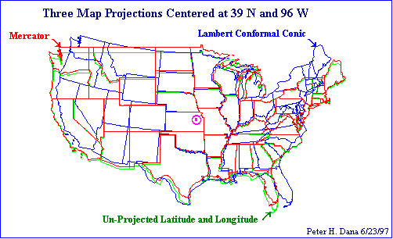

**2. Coordinate Systems**

**General.**

As described under map projections, traditional coordinate systems are based on a flat coordinate system. They are almost always a positive quadrant coordinate system, and are easier to develop and use over a small area. Recently, with improvements in computer processing capabilities, GIS and GPS systems are migrating toward using the spherical coordinate system of longitude and latitude.

**State Plane Coordinate System (SPCS).**

* The SPCS is primarily used in engineering applications by utility companies and local governments for doing accurate surveys. The SPCS is based on Transverse Mercator or Lambert Conformal conic projections with units in feet. States that elongate north to south normally use the Lambert Conformal. Those that are elongated east to west normally use the Transverse Mercator.
* Every State has at least one SPCS zone, some as many as five. Because they are so localized and tailored for the specific geographic area, distortion is very small.
* Nebraskahas two zones. There are between 100 and 150 zones in the US.
* Each zone is based on origins identified by each state. Each zone will have its on origin identified by some given number west and south of the south-western-most corner of the map. This means that positional numbers from the origin are expressed in positive terms. Normally locations are expressed in feet east and north of the origin. This can become difficult when areas may need to be identified across two zones.
* SPCS is identified on US Quadrangle maps by black graticule marks.

**Universal Transverse Mercator (UTM).**

* The UTM coordinate system is commonly used in GIS for larger scale areas within a certain UTM zone. The UTM projection is formed by using a transverse cylindrical projection, i.e., the standard line runs along a meridian of longitude. The effect is to minimize distortion in a narrow strip running pole to pole.
* UTM divides the earth into pole-to-pole zones 6 degrees of longitude wide. The first zone starts at the International Date Line (180 degrees east) and the last zone, 60, starts at 174 degrees east. Northings are determined separately for the areas north and south of the equator. Because distortion becomes extreme at northern latitudes, UTM is not normally used above 80 degrees North or South.

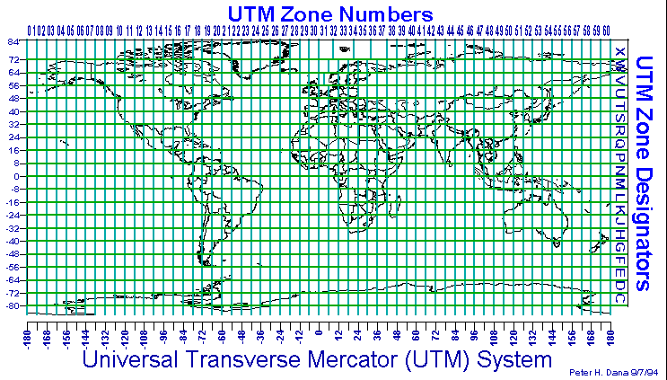

**United States Public Land Survey System.**

The US Public Land Survey System is a grid system based on a set of selected meridians, termed "principal meridians," and parallels, called "baselines." Distances are measured in the four cardinal directions from the initial point and are formed into townships, ranges, and sections. This system is primarily used for legal land description west of Ohio.

**3. GIS Capabilities**

**Basic Concepts.**

All GIS systems must be capable of converting projections and converting coordinates. This involves a lot of computer programming and computational power. At a minimum, a GIS must be able to convert digitized coordinates to latitude and longitude and reproject them on to a flat surface.

**Selecting the proper projection.**

In order to select the correct projection to use, we must analyze the object of our project. A projection should be selected which has a standard line which is centered on the area of focus. You must also determine if correct depiction of area, angle relationships, or distance accuracy is important. Distance may be especially difficult if correct depiction is required over a large area.

**4. Questions for Map Projections, Coordinate Systems, and GIS Capabilities**

1.      Describe the difference between a sphere and spheriod.

2.      Describe the four basic types of projections. When is each type normally used?

3.      Name an example of a conformal, equal area, and compromise map.

4.      Describe the State Plane Coordinate System using Nebraska as an example.

5.      Why is the UTM system not used North or South of 80 degrees latitude?

6.      Explain the key elements in selecting a projection to use in a GIS project.

Submitted by Dave Gay on 16 February 98.

Updated by Paul Woodward on December 6, 2004